**Require Content**Webiste Ambulance Pintar Indonesia

1. Header

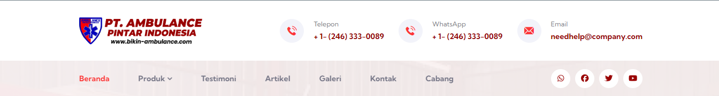

|  |  |  |
| --- | --- | --- |
| **No** | **Name** | **Content** |
| 1 | Single Logo  Example: | (image: png, transparent) |
| 2 | Full Logo  Example: | (image: png, transparent) |
| 3 | Phone/WhatsApp Number |  |
| 4 | Email |  |
| 5 | Facebook Link | (profile link) |
| 6 | X/Twitter Link | (profile link) |
| 7 | Youtube Link | (profile link) |
| 8 | Instagram Link | (profile link) |
| 9 | (additional social media ...) |  |

1. Hero Section

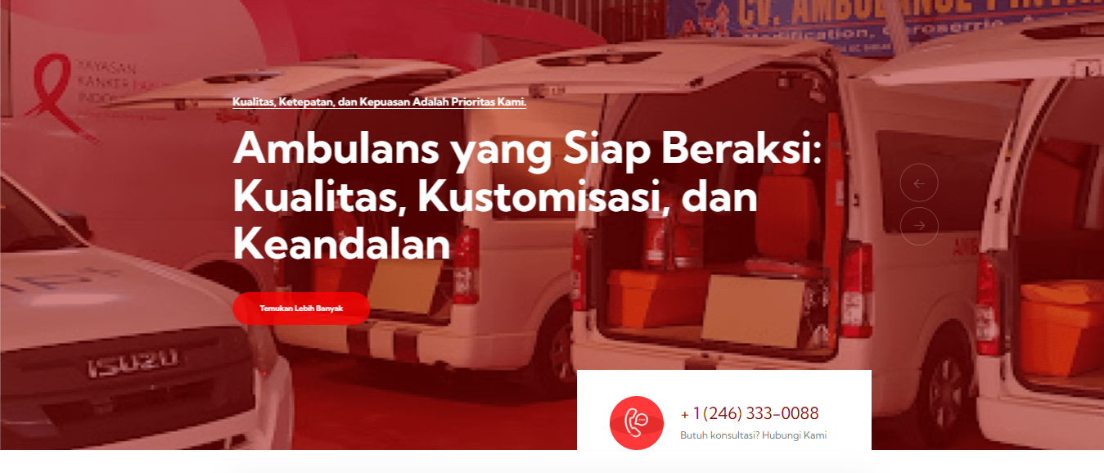

|  |  |  |
| --- | --- | --- |
| **No** | **Name** | **Content** |
| 1 | Slide Image 1 | (image: png, jpg, jpeg, svg) |
| 2 | Slide Image 2 | (image: png, jpg, jpeg, svg) |
| 3 | Slide Image 3 | (image: png, jpg, jpeg, svg) |
| 4 | Slide Image 4 | (image: png, jpg, jpeg, svg) |
| 5 | Slide Image 5 | (image: png, jpg, jpeg, svg) |
| 6 | (additional slide image) | (image: png, jpg, jpeg, svg) |

1. Testimonial Section

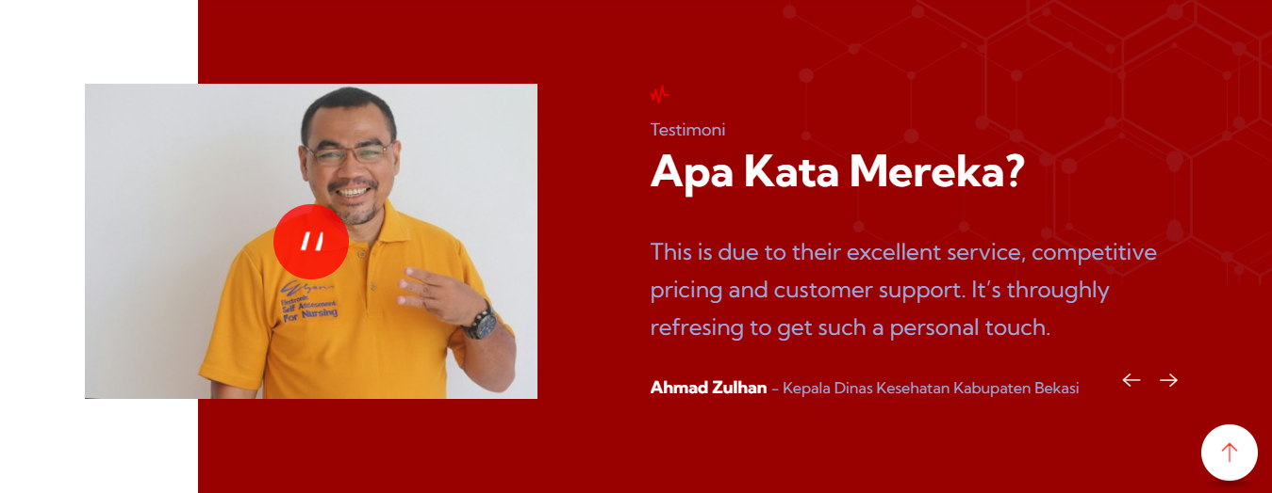

|  |  |  |  |  |
| --- | --- | --- | --- | --- |
| **No** | **Name** | **Institution** | **Testimony** | **Image** |
| 1 |  |  |  | (image: png, jpg, jpeg, svg) |
| ... |  |  |  | (image: png, jpg, jpeg, svg) |

1. Partner Section



|  |  |  |
| --- | --- | --- |
| **No** | **Institution** | **Image** |
| 1 |  | (image: png, jpg, jpeg, svg) |
| ... |  | (image: png, jpg, jpeg, svg) |

1. Client Section



|  |  |  |
| --- | --- | --- |
| **No** | **Institution** | **Image** |
| 1 |  | (image: png, jpg, jpeg, svg) |
| ... |  | (image: png, jpg, jpeg, svg) |

1. Offering Section

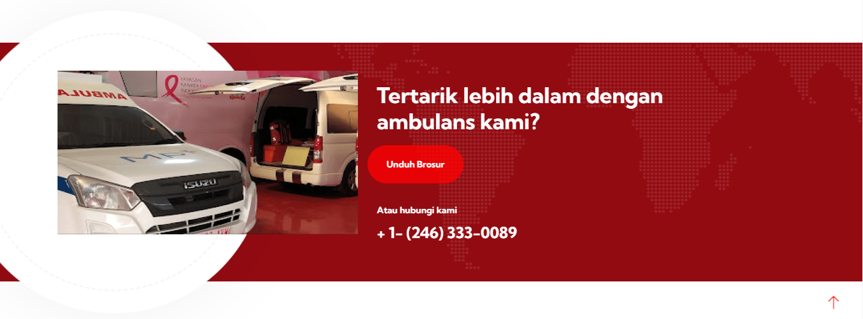

Image: (image: png, jpg, jpeg, svg)

Phone/WhatsApp Number:

Brosure Link: (gdrive link)

1. About Section

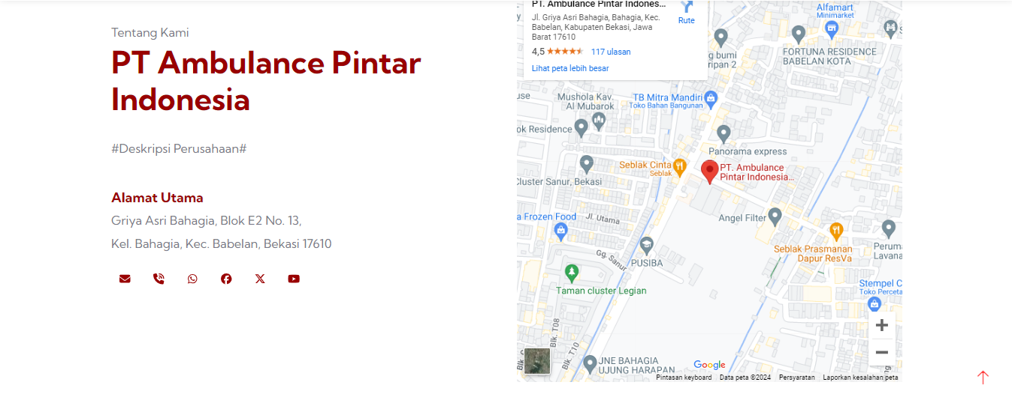

Company Desctiption:

Primary address:

Google maps link: